National Diabetes Month – Celebrate Life

Table of Contents

Overview 1
Partnership Toolkit Instructions 2
Partner Outreach Email 2
Drop-in Articles 3
E-Newsletter Copy Drafts 6
Social Media Posts and Images 9

Overview

November is National Diabetes Month, a chance to raise awareness about prediabetes and preventing type 2 diabetes, a major public health concern. CDC’s National Diabetes Prevention Program (National DPP) works to prevent or delay type 2 diabetes in people with prediabetes through lifestyle changes like increased physical activity, healthy eating, and stress management. This National Diabetes Month, we want to support your promotional efforts to potential lifestyle change program participants and engage partners to increase your reach.

This year’s National Diabetes Month content includes messaging with the theme Celebrate Life. This theme is designed to motivate participants by showing how the lifestyle change program can help them live their best life by preventing or delaying type 2 diabetes.

This bundle features the following promotional content:

- 2 Drop-In Articles. We recommend placing these in a newsletter or local newspaper/magazine and/or on your organization’s website. There is one for the beginning of the month and one for midway through the month to raise awareness of the risk of prediabetes and promote type 2 diabetes prevention.
- 4 E-newsletter Copy Drafts. Use this copy for email newsletters or listservs you may have. There is one email for each week of the month focused on a different aspect of the lifestyle change program and type 2 diabetes prevention.
- 8 Social Media Posts and Images. This year’s social media content was designed in the style of the 2020 National Diabetes Month campaign. We encourage you to reuse posts from last year in addition to these new posts to expand the content you offer on social media. There are 11 social media graphics and associated post copy for this year, organized with items from last year in a suggested posting calendar.

This year’s National Diabetes Month campaign features additional information on engaging partners to extend the reach of your efforts. Visit the 1815/1817 Box site to access the partner materials.

Partnership Toolkit Instructions

This observance is a chance to engage your partners to work with you and help raise awareness about prediabetes and type 2 diabetes. First, you will need to identify potential partners that align with your mission. Consider employers, community health centers, public health organizations, and other organizations that share the goal of supporting communities to live healthier lives. Also include any partners you already have a relationship with or have worked with in the past.

The partner outreach email template will help you connect with organizations in your area, introduce the lifestyle change program, and engage their help in your promotional efforts. When you contact potential partners, you can share the Partnership Toolkit, which includes materials designed specifically for partners to promote the lifestyle change program.

The toolkit includes e-newsletter drafts, social media posts, and images tailored for you and your potential partner organizations. You can customize these templates with the name of your organization, lifestyle change program name, and website link before sharing with partners.

Partner Outreach Email

To use: The following email can be used for outreach to potential partners to engage them in your National Diabetes Month efforts to promote the lifestyle change program.

Dear [insert name of organization or contact],
My name is [insert name], and I work with [insert your organization’s name]. We offer [insert name of your program], a lifestyle change program focused on preventing type 2 diabetes, which is part of the National Diabetes Prevention Program (National DPP) led by the Centers for Disease Control and Prevention (CDC).
It is estimated that 88 million US adults – more than 1 in 3 – have prediabetes. Prediabetes is a serious health condition where blood sugar levels are higher than normal, but not yet high enough yet for a diagnosis of type 2 diabetes. More than 84% of those with prediabetes don't know they have it. Having prediabetes increases the risk for type 2 diabetes, which can lead to severe health conditions like heart attack, stroke, blindness, kidney failure, and loss of toes, feet, or legs.

With such serious complications, preventing type 2 diabetes is a major public health concern. Prediabetes can be reversed by making healthy lifestyle changes. CDC’s National DPP works to promote healthier living to prevent or delay type 2 diabetes.

In honor of National Diabetes Month in November, we would like to collaborate with [name of partnering organization] to reach a broader audience and encourage more adults with prediabetes to enroll in [for LCPs: name of program]. Through the program, they’ll learn to make healthy food choices, get more physical activity, and manage stress to prevent or delay type 2 diabetes.

I am attaching a Partnership Toolkit, available in English and Spanish, to assist you in raising awareness around prediabetes and type 2 diabetes and learning how [name of partnering organization] could help people live healthier lives. We encourage you to use these materials by adding the drop-in articles and e-newsletter copy in communications with your members and/or posting the social media content on your organization’s platforms.
If you have any questions, please call or email me at the contact information below. I can provide more details about prediabetes and the lifestyle change program to support you in this collaborative effort.
Sincerely,
[insert name, title, and organization]
[insert email address and phone number]

Drop-in Articles

To use: You can post the following two articles on your organization’s website, publish in your organization’s newsletter, and/or send to a local newspaper or magazine. You can also download an image of your choice to use with the articles from the 1815/1817 Box site here.

Article 1: recommended for use at the beginning of National Diabetes Month

Learn To Prevent Type 2 Diabetes and Celebrate Your Best Life!

The past couple of years have brought many challenges to our families and communities, and we’ve come to recognize the importance of taking care of both our mental and physical health. Having good health impacts everything we do and the life we love.

According to the Centers for Disease Control and Prevention (CDC), 88 million US adults have prediabetes, meaning they have higher blood sugar levels than normal, but not yet high enough to be diagnosed as type 2 diabetes. More than 8 in 10 of those with prediabetes don’t know they have it. Prediabetes can lead to type 2 diabetes, but can be preventable with lifestyle changes.

Type 2 diabetes can put limits on what you enjoy most – having the health and energy for family, work, and hobbies that make life meaningful. It can also increase your risk for other serious health conditions like heart attack, stroke, or kidney failure. Type 2 diabetes isn’t reversible, but the good news is that prediabetes is! Every November, we recognize National Diabetes Month as a chance to share the risks of prediabetes and type 2 diabetes and to let you know about a proven program that can help you reverse prediabetes and prevent type 2 diabetes.

[Name of program] offers a lifestyle change program to help adults with prediabetes add healthy habits into their everyday lives as part of CDC’s National Diabetes Prevention Program (National DPP)[add details on in-person versus virtual, time, location, etc.]. In the program, you’ll meet people like you who are also working to improve their health and lower their risk for type 2 diabetes. Our trained Lifestyle Coaches lead the program and will help you find what works best for you and encourage you on your health journey.

[Insert testimonial quote from a coach or participant of your program about the benefits of the lifestyle change program, You can use the quote below, or if you prefer you can replace it with one of your own.

Quote for You to Use

“It’s the complete program that makes the difference. It’s not just about exercise. It’s about understanding what’s good to eat and all the stuff that comes up with stress and how to take care of your heart.” (Tom Triscari, participant)

While the benefits speak for themselves, it can feel overwhelming to think about how to live healthier. You may think you don’t have the time to be more active or the desire to give up all your favorite foods. With the lifestyle change program, though, we celebrate your life and show how living healthy can add to that, not take away from it. It’s possible to make small changes that make a big difference, like adding some extra veggies to your favorite meal or playing outside with a pet or your grandkids to be more active.

Participants in the program aim to lose 5-7% of their body weight, which is 10-14 pounds for a 200-pound adult. They also aim to get 150 minutes of physical activity each week. People in the lifestyle change program who make these changes can cut their risk of type 2 diabetes in half.

We want you to enjoy your best life, full of time with family, friends, and the activities you care about. By taking steps to eat healthier, get more physical activity, solve problems that can slow your progress, and manage stress, you can set yourself up to prevent or delay type 2 diabetes. You do so much for others, so make sure to take some time for yourself too and learn more today about the lifestyle change program.

What steps can you take to make healthy habits a priority? Take CDC’s 1-minute prediabetes risk test, and visit our website for more information: [link to program website]. Let’s celebrate life this National Diabetes Month and start your path to better health!

Article 2: recommended for use midway through National Diabetes Month.

Stepping Into Better Health During National Diabetes Month

Healthy living is an ongoing journey – one that’s important to keep you energized for the things that matter most. Celebrate the people and activities you love by prioritizing healthy habits to keep living your best life.

Did you know that 88 million adults in the United States have a condition called prediabetes? This means a person’s blood sugar levels are higher than normal, but not yet high enough to be considered type 2 diabetes. While prediabetes can be reversible, type 2 diabetes can’t -- and it can lead to increased risk for other serious health problems like heart attack, blindness, and kidney failure.

If you have prediabetes, there are healthy changes you can make that can prevent or delay type 2 diabetes. [Name of program] is a lifestyle change program through the Centers for Disease Control and Prevention National Diabetes Prevention Program (National DPP) designed to help you do just that. November is National Diabetes Month and a chance to think about improving your health. Here at [name of organization], we offer the lifestyle change program [details on time, location, etc.] with trained Lifestyle Coaches whose goal is to help you enhance your life with healthy habits that work for you.

What will the lifestyle change program help you do?

Eat healthier – Eating a balance of healthy foods is one of the biggest factors in losing weight and having better health overall. Small swaps like switching out starchy vegetables like potatoes for leafy greens like a salad can make a big impact. You’ll also learn how reducing portion sizes lets you enjoy some of your favorite foods while limiting unhealthy amounts of salt, fat, and sugar.

Get more physical activity – Learn ways to move more that you’ll actually enjoy! You don’t have to run for miles or spend hours in the gym to be active. Something as simple as a walk with a friend or your partner or dancing to some music while doing household chores can improve your health and energy.

Manage stress – Stress affects your health in many ways, and learning to reduce stress can help prevent type 2 diabetes. Getting 8 hours of sleep each night and building in short breaks at work are examples of stress management methods that make a difference for your health.

With practical tips that are proven to work, you’ll develop habits that will last long after the program is done. By losing 5-7% of your body weight (10-14 pounds for a 200-pound adult) and adding 150 minutes of weekly physical activity to your routine, you can cut your risk for type 2 diabetes in half!

Instead of taking away from what you enjoy doing or how you spend your time, we can help you make small changes that fit into your lifestyle. You’ll do all of this with the support of your Lifestyle Coach during group sessions with others also looking to reverse prediabetes. Living healthier may feel overwhelming, but with a team behind you, you can achieve your goals and make positive changes for the future.

So, ready to get started? Learn more about prediabetes and the lifestyle change program at [insert link to program website]. We’re here to support you on your health journey so you don’t have to do it alone. Sign up today to find a community working to prevent or delay type 2 diabetes so you can keep on celebrating the life you love all year long.

E-Newsletter Copy Drafts

To use: The following e-newsletter copy can be used to promote the program in online e-newsletters and email blasts. Consider placements in a community newsletter, local health care provider or network newsletter, and/or faith-based newsletter.

Week 1 E-newsletter Copy

Subject: Live Your Best Life During National Diabetes Month

After the difficult times over the past couple of years, many of us have made great sacrifices and experienced personal loss. We’ve become more mindful of our health and how it impacts our lives and those we love.

November is National Diabetes Month, a time to reverse prediabetes and prevent type 2 diabetes, a health condition that can lead to other serious issues like heart attack and stroke. According to the Centers for Disease Control and Prevention (CDC), 88 million US adults have prediabetes, where blood sugar levels are higher than normal but not high enough yet for a type 2 diabetes diagnosis.

Prediabetes can develop into type 2 diabetes unless you make some healthy lifestyle changes. The good news is that prediabetes is reversible, and [name of organization] is here to help. We offer a lifestyle change program as part of CDC’s National Diabetes Prevention Program (National DPP) to support your health goals and help you to live your best life.

How can the lifestyle change program help you this National Diabetes Month and all year round? You’ll learn about:
- Your risk for type 2 diabetes and ways to prevent or delay it
- Small food changes that keep you healthier and still allow you to enjoy some of the dishes you love
- Strategies for managing stress, which can cause health issues
- Ways to get moving that don’t involve intense workouts or hours in the gym
- What motivates you to keep going on your journey to better health
- And so much more!

We offer the lifestyle change program [details on class offerings such as time, location, Spanish-speaking, virtual, etc.]. Our Lifestyle Coach and other participants will help you find strategies for healthy living that work for you – and make the process more enjoyable! Are you ready to start living your best life and lower your risk for type 2 diabetes? Read more at [insert link to program website].

Week 2 E-newsletter Copy

Subject: Myth Busting: What Better Health Actually Means

What comes to mind when you think of healthy living? It may seem overwhelming to think about, but it is so important to achieving your best life now and in the future!

Over 88 million US adults have prediabetes, where blood sugar levels are higher than normal, though not high enough yet for a type 2 diabetes diagnosis. Having prediabetes increases your risk for type 2 diabetes and other serious health problems. November is National Diabetes Month, and we want to take this opportunity to tell you that reversing prediabetes and living healthier are possible! [Name of organization] offers a lifestyle change program through CDC’s National Diabetes Prevention Program to help you prevent or delay type 2 diabetes.

There are myths about living healthier that may discourage you from trying – here are some we want to bust.

- “I have to spend hours in the gym working out really hard to get healthier.” – FALSE!
Adding more physical activity to your day isn’t just about high-intensity workouts in a gym. Even walking, stretching, or playing with a pet can improve your physical health.

- “Living healthier means I can’t eat any of my favorite foods.” – FALSE!
It’s important to eat healthy, but it’s possible to enjoy some favorite dishes and sweet treats in moderation. By reducing portion sizes and adding in more fresh fruits and vegetables, you CAN have your cake and eat it too.

- “Even if I wanted to, I just don’t have the time to be healthy.” – FALSE!
We know you have a busy schedule. That’s why the lifestyle change program is designed to help you find healthy habits that fit into your routine. You’ll learn ways to get more physical activity and manage stress to see the positive impact on your overall health.

Curious to learn more about what better health means and how the lifestyle change program can help you live your best – and healthiest – life? Then be sure to check out [insert organization website] for more information today!

Week 3 E-newsletter Copy

Subject: 60 Seconds – All It Takes To Start Your Health Journey

There are lots of things competing for your attention every day – your job, your family, your home, and so much more. With everything you have going on, it may seem like you don’t have enough time to prioritize your health. We understand you’re busy, and that’s why [name of organization] is only asking you for 60 seconds today to support your health.

What can you do with a minute? Take the Centers for Disease Control and Prevention’s (CDC) 1-minute Prediabetes Risk Test to learn about your risk for prediabetes, a condition where your blood sugar levels are higher than normal, though not yet high enough yet to be diagnosed as type 2 diabetes. Without changes to your lifestyle, prediabetes can lead to type 2 diabetes.

Type 2 diabetes is a health condition that can lead to other serious conditions like blindness, heart attack, and stroke. Here at [name of organization], we are dedicated to helping you learn to prevent or delay type 2 diabetes. We offer CDC’s National Diabetes Prevention Program lifestyle change program to do just that.

If you’ve taken the risk test and learned you may have prediabetes, here are some easy next steps for you to take.
- Learn more about [name of lifestyle change program] by visiting [link to program website].
- Get 30 minutes of physical activity today; try going for a short walk on your lunch break or playing music to get moving while doing household chores.
- Make a list of fruits and veggies you enjoy eating. Next time you’re at the grocery store, add some of those to your cart instead of snacks high in salt or sugar like chips or pastries.
- Find 5 minutes in your day just to pause and relax. Taking some time to lower your stress can benefit your health in big ways!

During National Diabetes Month this November, we want to help you celebrate your best life by learning to live healthier. Take care of yourself by preventing type 2 diabetes so you can keep enjoying what you love most.

Week 4 E-newsletter Copy

Subject: Celebrating Progress Towards a Healthier You

This National Diabetes Month, we’ve been raising awareness about prediabetes – a condition that 88 million US adults have, according to the Centers for Disease Control and Prevention (CDC). Prediabetes is where blood sugar levels are higher than normal but not high enough yet for a type 2 diabetes diagnosis. That’s why [name of organization] offers a lifestyle change program through CDC’s The National Diabetes Prevention Program (National DPP). The program is here to help you prevent or delay type 2 diabetes and is also a perfect opportunity for you to involve your family and friends.

Throughout the month, we’ve been promoting ways to eat healthier, get more physical activity, and manage stress. We want you to enjoy your best and healthiest life and celebrate any changes you’ve made to get started on that journey!

Now that you’ve learned some ways to live healthier, the lifestyle change program is here to support your health goals. What’s the benefit to enrolling in a program like this?

- Guidance from trained Lifestyle Coaches to support and find what works for you.
- Support from fellow participants.
- Accountability on your journey to prevent or delay type 2 diabetes.
- Encouragement and tips to stick with your goals, even after the program ends.

You have a lot to be proud of as you take steps to prevent type 2 diabetes! You are not on this journey alone. The National DPP can help you prevent or delay type 2 diabetes by developing healthy habits that enable you to lose 5-7% of your body weight and get more active. Deciding to live healthier along with those you love can help keep you motivated and gives you a shared goal to be excited about.

Learning to live healthier takes commitment and effort, and we celebrate you for beginning that journey! Keep the momentum going and enroll in the lifestyle change program today. Read more at [insert link to program website].

Social Media Copy and Images

To use: You can use the following social media post copy and images on Facebook, Instagram, and Twitter. Photos are available for download on the 1815/1817 Box site. Links have been provided below each photo.
Post Copy | Recommended Image
Whether it’s for family, work, or a dream you’ve always had, we encourage you to live healthier for your best life with CDC’s National Diabetes Prevention Program lifestyle change program. What’s your reason for living healthier? Tell us in the comments. [link to program website] | 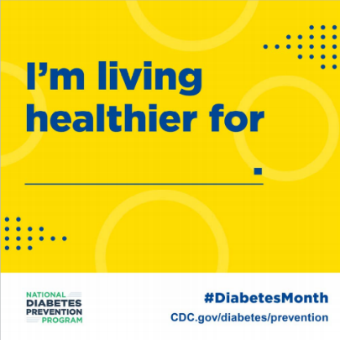  Download Link
For Glenn, losing weight isn’t just the destination, it’s also the journey. As a truck driver, Glenn found the tips from CDC’s National Diabetes Prevention Program lifestyle change program kept him on the road to better health. Learn more: [link to program website]. | 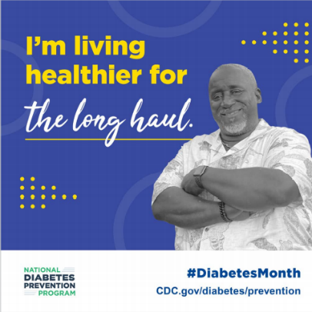  Download Link
For Jack and Joyce, it’s about retiring from work, not from life. They live healthier together through CDC’s National Diabetes Prevention Program lifestyle change program to enjoy more of what matters most. Learn more at [link to program website]. | 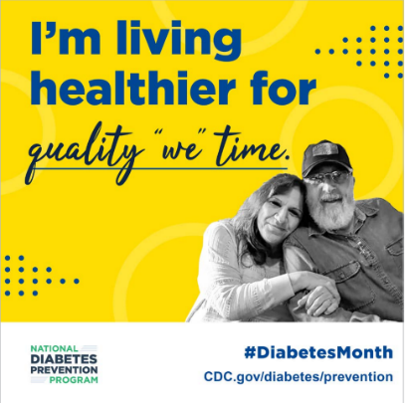  Download Link
For Olga, living healthier means creating new traditions in her family and sharing what she’s learned through CDC’s National Diabetes Prevention Program lifestyle change program. You can pass on a healthy lifestyle to your loved ones too! Learn more at [link to program website]. | 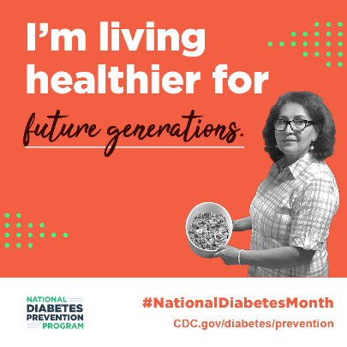  Download Link
For Elvia, small changes to her lifestyle made all the difference in learning to prevent or delay type 2 diabetes. Get support for your own health journey with CDC’s National Diabetes Prevention Program lifestyle change program. Learn more at [link to program website]. | 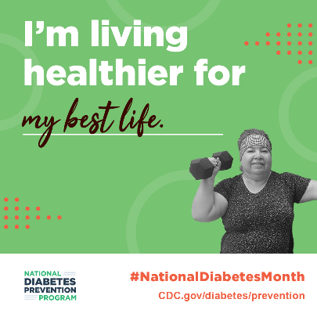  Download Link
88 million US adults have prediabetes. If you have prediabetes, healthy lifestyle changes can help keep you from developing type 2 diabetes. Learn how CDC’s National Diabetes Prevention Program lifestyle change program can help you! [link to program website] | 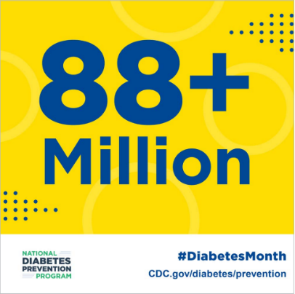  Download Link
More than 8 in 10 US adults with prediabetes don’t know that they have it. If you’re at risk, it’s important for you to take action. CDC’s National Diabetes Prevention Program lifestyle change program is here to help you do just that. [link to program website] | 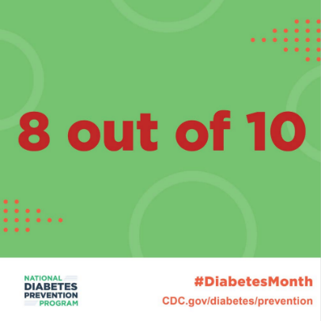  Download Link
Did you know that more than 1 in 3 Americans has prediabetes, putting them at risk for type 2 diabetes? CDC’s National Diabetes Prevention Program lifestyle change program is here to help you live healthier and lower that risk. Learn more: [link to program website]. | 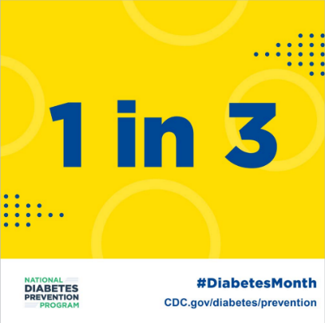  Download Link
With CDC’s prediabetes risk test, it takes just 60 seconds to find out if you are at risk for type 2 diabetes. Take the test and take action. Learn more at https://www.cdc.gov/prediabetes/risktest/index.html | 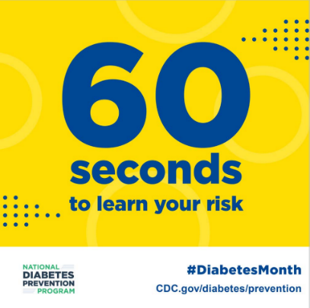  Download Link
CDC’s National Diabetes Prevention Program lifestyle change program can help people with prediabetes cut their risk for type 2 diabetes in half! Learn more at [link to program website]. | 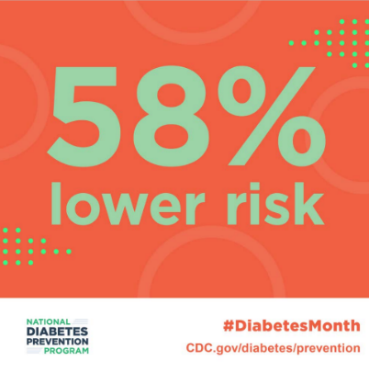  Download Link
Every 21 seconds, someone is diagnosed with diabetes in the US. We want to do something about that. CDC’s National Diabetes Prevention Program lifestyle change program can help you live healthier and lower your risk of type 2 diabetes. Learn more at [link to program website]. | 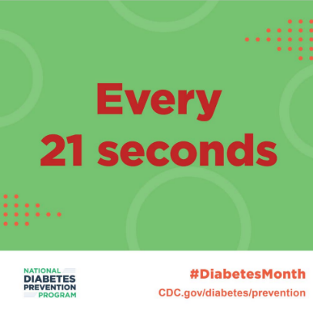  Download Link

