National Diabetes Month – Celebrate Life

Overview & Instructions

Please note: The yellow highlighted text throughout is for the organization offering the lifestyle change program (LCP) to fill in before sharing with potential partners. This note can be removed once you’ve customized this bundle before sending to potential partners.

Please note: The teal highlighted text throughout is for partner organizations to customize and fill in when using the content templates.

It is estimated that 88 million US adults – more than 1 in 3 – have prediabetes. Prediabetes is a serious health condition where blood sugar levels are higher than normal, but not yet high enough for a diagnosis of type 2 diabetes. More than 84% of those with prediabetes don't know they have it. Having prediabetes increase people’s risk for severe health conditions like heart attack, stroke, blindness, kidney failure, and loss of toes, feet, or legs.

With such serious consequences, preventing type 2 diabetes is a major public health concern. Prediabetes can be reversed by making healthier lifestyle decisions. The CDC’s National Diabetes Prevention Program (National DPP) works to promote healthier living including physical activity, healthy eating, and stress management to prevent or delay type 2 diabetes.

In honor of National Diabetes Month taking place in November, we would like to collaborate with [name of partnering organization] to reach a broader audience and encourage more adults with prediabetes to live a healthier and happier life by enrolling in [for LCPs: name of program]. We invite you to participate in this campaign to encourage your audience to eat better, get more physical activity, and manage stress to prevent or delay type 2 diabetes.

[for LCPs: name of organization] offers a lifestyle change program to help people reduce their risk for type 2 diabetes and live healthier lives. [Name of program] is part of the National Diabetes Prevention Program led by the Centers for Disease Control and Prevention and can help people live healthier and happier lives. We believe our mission align with yours and would like to partner with you to expand our reach and encourage others to choose healthier foods, get more physical activity, and manage stress to prevent or delay type 2 diabetes.

The following materials have been designed to help you get involved in this effort as a partner and promote healthy living and type 2 diabetes prevention during National Diabetes Month.

This content includes messaging with the theme Celebrate Life. The content is organized by weekly themes, with each week of the month having tailored content focused on how to celebrate your life by living healthier and happier.

This toolkit for partners features:

- 4 E-newsletter Copy Drafts. This copy can be used for email announcements as part of your organization’s internal communications. There is one email for each week of the month focused on a different aspect of the lifestyle change program or type 2 diabetes prevention.
- 11 Social Media Graphics and Post Copy. There are 11 social media graphics and associated post copy for use throughout the month as part of our 2021 National Diabetes Month campaign.

E-Newsletter Copy

To use: The following e-newsletter copy can be used to promote the program in online e-newsletters and email blasts. Consider placements in a community newsletter, local health care provider or network newsletter, and/or faith-based newsletter.

Week 1 E-newsletter

Subject: Live Your Best Life During National Diabetes Month

After the public health emergency of COVID and difficult times the past couple of years, many of us have made great sacrifices and experienced personal loss. We’ve become more mindful of our health and how it impacts our lives and those we love.

November is National Diabetes Month, a time to support the prevention of type 2 diabetes, a health condition that can lead to other serious issues like heart attack and stroke. According to the Centers for Disease Control and Prevention (CDC), 88 million U.S. adults have prediabetes, where blood sugar levels are higher than normal and, on the way, to being type 2 diabetes.

If you have prediabetes, you may develop type 2 diabetes without healthy lifestyle changes. The good news is that prediabetes is reversible, and we have partnered with [for LCPs: name of organization] to help you prevent type 2 diabetes. [for LCPs: name of organization] offers a lifestyle change program as part of CDC’s National Diabetes Prevention Program to support your health goals and encourage you to live your best life.

How can the lifestyle change program help you this National Diabetes Month and all year round? With the program you’ll learn about:
- Your risk for type 2 diabetes and ways to prevent or delay it
- Small food changes that keep you healthier and still allow you to enjoy some of the dishes you love
- Strategies for managing stress, which is often a big cause of health issues
- Ways to get moving that don’t involve intense workouts or hours in the gym
- What motivates you to keep going on your journey to better health
- And so much more!

[for LCPs: name of organization] offers the lifestyle change program [details on class offerings such as time, location, Spanish-speaking, virtual, etc.]. Deciding to live healthier with the lifestyle change program will help hold you accountable – and make the process more enjoyable! Are you ready to start living your best life and lower your risk for type 2 diabetes? Read more at [for LCPs: insert link to program website].

Week 2 E-newsletter

Subject: Mythbusting: What Better Health Actually Means

What comes to mind when you think of healthy living? It may seem hard or overwhelming to think about, but it is so important to your overall health!

The Centers for Disease Control and Prevention (CDC) recognizes type 2 diabetes as a serious health concern for many Americans. Over 88 million U.S. adults have prediabetes, where blood sugar levels are higher than normal, though not yet type 2 diabetes. Since November is National Diabetes Month, we want to take this opportunity to tell you that reversing prediabetes and living healthier aren’t impossible! [Name of partnering organization] has partnered with [for LCPs: name of organization] to encourage you to join a lifestyle change program through CDC’s National Diabetes Prevention Program to help you prevent or delay type 2 diabetes.

The lifestyle change program is about sharing healthy habits that work for you and make a difference. There are many myths about living healthier, so here are some we want to bust.

- “I have to spend hours in the gym working out really hard to get healthier.” – FALSE!
Adding more physical activity to your day isn’t about high intensity workouts in a gym. Even walking, stretching, or playing with a pet can improve your physical health.

- “Living healthier means I can’t eat anymore of my favorite foods.” – FALSE!
It is important to eat healthy, but it’s possible to enjoy some favorite dishes and sweet treats in moderation. By reducing portion sizes and adding in more fresh fruits and vegetables, you can have your (small slice of) cake and eat it too.

- “Even if I wanted to, I just don’t have the time to be healthy.” – FALSE!
We know you have a busy schedule, and the lifestyle change program is designed to help you find healthy patterns that fit into your routine. You’ll learn ways to incorporate movement and stress management into what you already do and see the positive impact on your overall health.

Curious to learn more about what better health means and how the lifestyle change program can help you lead your best – and healthiest – life? Then be sure to check out [insert link to program website] for more information today!

Week 3 E-newsletter

Subject: 60 Seconds – All It Takes to Start Your Health Journey

There are many things that require your attention in a day – your job, your family, your home, and so much more. With everything you have going on, it may seem like you don’t have enough time to prioritize your health. We understand you’re busy, and that’s why [name of organization] is only asking you for 60 seconds today to support your health.

What can you do with a minute? Take the Centers for Disease Control and Prevention’s (CDC) one-minute Prediabetes Risk Test to learn about your risk for prediabetes, a condition where your blood sugar levels are higher than normal, though not yet high enough to be type 2 diabetes. Without changes to your lifestyle, you may develop type 2 diabetes within 5 years if you have prediabetes.

Type 2 diabetes is a health condition that can lead to other serious conditions like blindness, heart attack, and stroke. Here at [name of partnering organization], we are dedicated to helping you learn to prevent or delay type 2 diabetes. That’s why we are partnering with [for LCPs: name of your organization], which offers the National Diabetes Prevention Program lifestyle change program. It can help you prevent or delay type 2 diabetes by learning to eat favorite foods in healthier ways, getting more physical activity, and managing stress for better health.

If you’ve taken the risk test and learned you may have prediabetes, here are some easy next steps for you to take.
- Learn more about [name of lifestyle change program] by visiting [link to program website].
- Get 30 minutes of physical activity today; try going for a short walk on your lunch break or playing music to get you moving while doing household chores.
- Make a list of fruits and veggies you enjoy eating. Next time you’re at the grocery store, add some of those to your cart instead of snacks high in salt or sugar like chips or pastries.
- Find even 5 minutes in your day just to pause and relax. Taking some time to lower your stress can actually benefit your health in big ways!

During National Diabetes Month this November, we want to ensure you celebrate your best life by learning to live healthier. Working to prevent or delay type 2 diabetes is a way to take care of yourself so you can keep enjoying what you love most.

Week 4 E-newsletter

Subject: Celebrating Progress Towards a Healthier You

This National Diabetes Month, we’ve been raising awareness about prediabetes – a condition that 88 million U.S. adults have according to the Centers for Disease Control and Prevention (CDC). Prediabetes is when blood sugar levels are higher than normal and can lead to type 2 diabetes without healthy routine changes. That’s why we are partnering with [for LCPs: name of your organization], which offers the National Diabetes Prevention Program lifestyle change program. It can help you prevent or delay type 2 diabetes by learning to eat favorite foods in healthier ways, getting more physical activity, and managing stress for better health.

Throughout the month, we’ve been collaborating with [for LCPs: name of organization] to promote ways to get healthier through food, physical activity, and managing stress. We want you to enjoy your best and healthiest life possible, and we celebrate any changes you’ve made to get started on that journey!

Now that you’ve learned some ways to live healthier, the lifestyle change program is here to help you continue with your health goals. What’s the benefit to enrolling in a program like this?

- Guidance from trained Lifestyle Coaches to support you in finding what works for you.
- Support from peers participating in the lifestyle chance program with you.
- Accountability to keep you on track to prevent or delay type 2 diabetes.
- Encouragement and tips to stick with your goals, even after the program ends.

You have a lot to be proud of as you take steps to prevent type 2 diabetes, and this isn’t something you have to do alone! The lifestyle change program is here to help you in that process, and it’s also a perfect opportunity for you to involve your family and friends. Deciding to live healthier along with those you love can help keep you motivated and gives you all a shared goal to be excited about.

Learning to live healthier takes intention and effort, and we celebrate you for beginning that journey! Keep the momentum going and enroll in the lifestyle change program today. Read more at [insert link to program website].

Social Media Copy and Images

To use: You can use the following social media post copy and images on Facebook, Instagram, and Twitter. Photos are available in the zip folder attached to your outreach email.

Post Copy | Recommended Image
Whether it’s for family, work, or a dream you’ve always had, we encourage you to live healthier for your best life with CDC’s National Diabetes Prevention Program lifestyle change program. What’s your reason for living healthier? Tell us in the comments. [link to program website] | 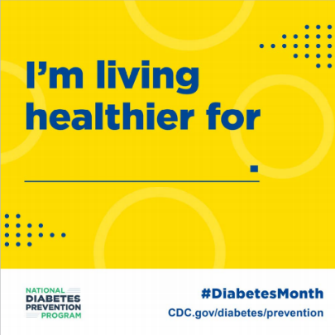
For Glenn, losing weight isn’t just the destination, it’s also the journey. As a truck driver, Glenn found the tips from CDC’s National Diabetes Prevention Program lifestyle change program kept him on the road to better health. Learn more: [link to program website]. | 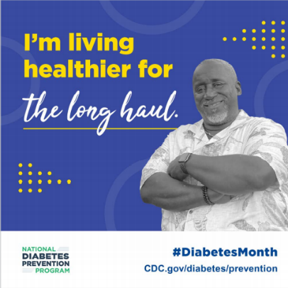
For Jack and Joyce, it’s about retiring from work, not from life. They live healthier together through CDC’s National Diabetes Prevention Program lifestyle change program to enjoy more of what matters most. Learn more at [link to program website]. | 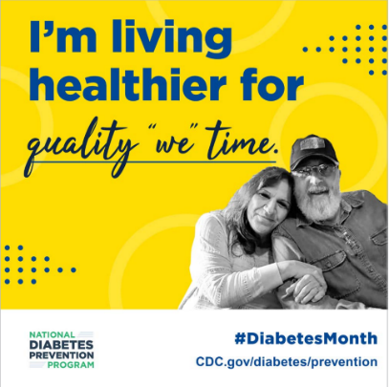
For Olga, living healthier means creating new traditions in her family and sharing what she’s learned through CDC’s National Diabetes Prevention Program lifestyle change program. You can pass on a healthy lifestyle to your loved ones too! Learn more at [link to program website]. | 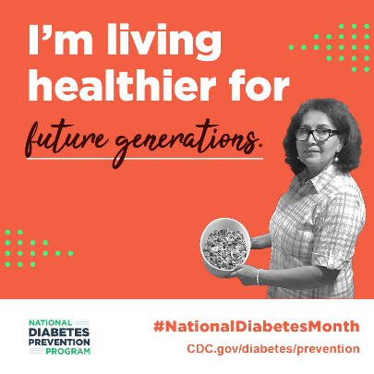
For Elvia, small changes to her lifestyle made all the difference in learning to prevent or delay type 2 diabetes. Get support for your own health journey with CDC’s National Diabetes Prevention Program lifestyle change program. Learn more at [link to program website]. | 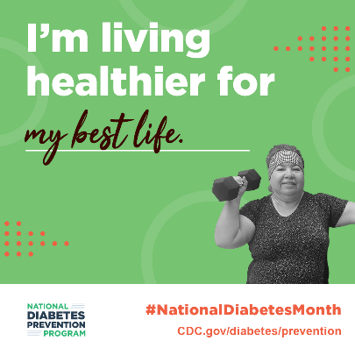
88 million US adults have prediabetes. If you have prediabetes, healthy lifestyle changes can help keep you from developing type 2 diabetes. Learn how CDC’s National Diabetes Prevention Program lifestyle change program can help you! [link to program website] | 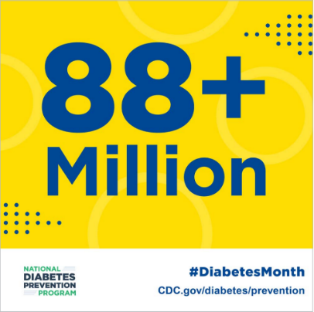
More than 8 in 10 US adults with prediabetes don’t know that they have it. If you’re at risk, it’s important for you to take action. CDC’s National Diabetes Prevention Program lifestyle change program is here to help you do just that. [link to program website] | 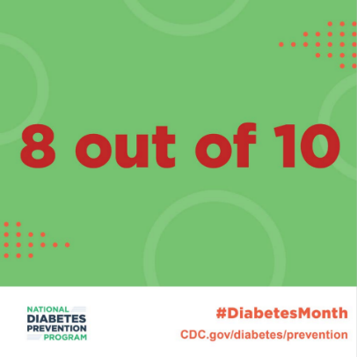
Did you know that more than 1 in 3 Americans has prediabetes, putting them at risk for type 2 diabetes? CDC’s National Diabetes Prevention Program lifestyle change program is here to help you live healthier and lower that risk. Learn more: [link to program website]. | 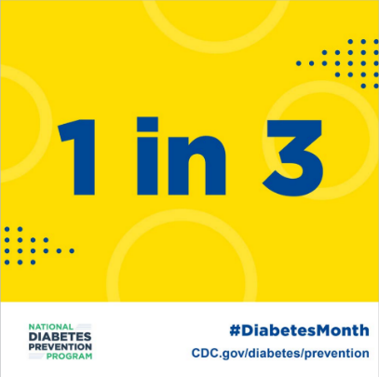
With CDC’s prediabetes risk test, it takes just 60 seconds to find out if you are at risk for type 2 diabetes. Take the test and take action. Learn more at https://www.cdc.gov/prediabetes/risktest/index.html | 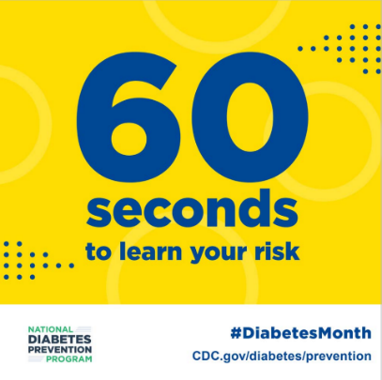
CDC’s National Diabetes Prevention Program lifestyle change program can help people with prediabetes cut their risk for type 2 diabetes in half! Learn more at [link to program website]. | 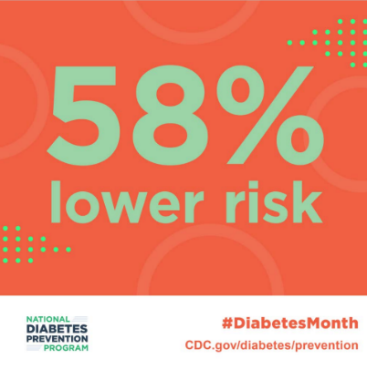
Every 21 seconds, someone is diagnosed with diabetes in the US. We want to do something about that. CDC’s National Diabetes Prevention Program lifestyle change program can help you live healthier and lower your risk of type 2 diabetes. Learn more at [link to program website]. | 