April – Building for the Future (Middle Eastern and North African Audience)

Part I: Introduction for Recipients

Audience Insights and Tips for Cultural Tailoring

Many Middle Eastern and North African (MENA) people are at higher risk for developing type 2 diabetes yet may be unaware of their increased risk. They may also have less access to linguistically or culturally tailored diabetes education and type 2 prevention support¹. The Centers for Disease Control and Prevention’s (CDC) National Diabetes Prevention Program (National DPP) is an inclusive program that serves diverse groups, such as those from MENA communities.
Effective delivery of the National DPP lifestyle change program can require cultural tailoring to meet the needs of participants. Consider these questions if your organization would like to engage with MENA communities.
Should you offer your program in another language? While many MENA people speak English, some are more comfortable speaking in another language, particularly Arabic, and may prefer a program in that language. Determine what language people in your community prefer for both written and oral communication. Also consider their level of health literacy.
Are materials tailored to your audience? Both your promotional and program materials can be adapted to the MENA people in your community. If your program is being offered in Arabic or other language, materials should be offered in that language as well. If your program is only available in English, we don’t recommend creating promotions in another language. Participants may expect that the program will be offered in that language as well. If your program is English only, consider that some individuals may have lower literacy levels and will benefit from plain-language practices and communications that rely on visual elements. CDC’s Clear Communication Index is a research-based tool to help you develop and assess communication materials for your intended audience.
Use images in your materials that reflect your audiences. Keep in mind that the MENA audience comes from many different cultural and religious backgrounds and reflect that in the images you choose. Test your materials to confirm they are appropriate for your audience. One way to do this is to through a survey with members of the community; you can ask them to review the materials and then follow up with questions on efficacy and reaction.
Is the program accessible to potential participants? Transportation and unemployment are social determinants of health that greatly impact the MENA population in some communities. Getting to the program site or having the financial stability to afford transportation to attend regularly may be barriers to participation. Consider ways to address these barriers. For example, offer hybrid/virtual programs or incentives to support participation, such as gift cards to local grocery stores or bus tokens for public transportation.
How can faith impact participation in the program? A large segment of the MENA population practices the Islamic faith. They may engage in fasting, which could be considered when making recommendations on healthy eating and physical activity. For example, during Ramadan, practicing Muslims fast from dawn until sunset for a month, which can mean less energy for exercise during the day. Your program may encourage everyday activities such as household chores that get people moving without adding more physical activity to their routine when they may be more tired. This helps participants maintain healthy habits. Additionally, encouraging reasonable portion sizes and healthy swaps is a great way for your organization to promote lifestyle habits that are sustainable while respecting people’s culture and traditions. For additional support, please see Working with Islamic Faith-Based Organizations.
What other adaptations may encourage program enrollment? Members of the MENA audience may prefer separate classes for men and women. Some women may not feel comfortable going to gyms or other mixed-gender settings to work out. You may want to provide a variety of suggestions for physical activity that allow for flexibility and privacy to respect personal preferences and customs. Engage Lifestyle Coaches who are members of the MENA community so that they can understand and empathize with participants. Provide coaches with culturally relevant resources, such as translations of diabetes-related materials or recommendations for food stores and markets most commonly used by the local MENA community.
Who can support your efforts with your local MENA community? Engage community partners and organizations serving those you want to reach, especially when you are first beginning to work with a population in your area. You can gain insight into your audience’s values, customs, and traditions; find culturally relevant resources; determine linguistic preferences and available translation services; and identify messages that will most resonate with the community. Trusted organizations who are already serving the audience can help you engage MENA people in your area and position your lifestyle change program for genuine connection and cultural respect and understanding. Consider MENA-owned food stores/markets, cultural associations, faith-based organizations, local food banks/social support organizations, or other public services serving the MENA community as potential partners for your program.
By asking these questions and learning about the community you are trying to engage, you will have the insight needed to tailor your promotions and lifestyle change program to best ensure health equity and support type 2 diabetes prevention for all.

Part II: Marketing and Communication Materials for Public Use

Drop-In Article

To Use: You can post this article to your organization’s website, publish it in your organization’s newsletter, and/or send it to a local newspaper or magazine. Fill in the yellow highlighted portions with details specific to your lifestyle change program.

Building for the Future – With Better Health

What do you imagine when you picture the future? Is it your family gathered at a celebration? Is it seeing your kids go to college or find a career they love? Maybe you imagine holding grandkids or spending time with your partner. These kinds of moments give life meaning, and being healthy as you get older allows you to have the energy and ability to actively participate in them.

Type 2 diabetes is a serious condition that impacts millions of Americans – and their ability to be healthy for the things that matter to them. Type 2 diabetes occurs when your body has a problem turning the food you eat into energy. This causes your body’s blood sugar levels to be much higher than normal and can lead to other problems like heart disease or vision loss. Did you know that if you are from a Middle Eastern or North African (MENA) background, your risk of developing type 2 diabetes may be higher than the average adult living in America?

The [name of organization] is committed to helping people prevent type 2 diabetes and have a healthier future through the National Diabetes Prevention Program (National DPP) lifestyle change program. Adults who are diagnosed with prediabetes, where blood sugar levels are higher than normal but not yet high enough to be type 2 diabetes, are invited to be a part of [name of program]. This lifestyle change program at [name of organization] is a part of the Centers for Disease Control and Prevention’s (CDC) National DPP and supports MENA adults on their health journey.

The program is set up as a series of group classes led by trained Lifestyle Coaches who can help you find ways to live better and reverse your prediabetes so you can prevent or delay type 2 diabetes. Ahlam is a Lifestyle Coach with a MENA community in Michigan who sees the social support offered in the lifestyle change program as one of its key benefits. She says, “Participants get one-on-one support from us, and when we hear what participants want and need, we tailor our class for them.”

This can mean simple food swaps and portion recommendations to eat better while still enjoying traditional foods and ingredients. Lifestyle Coaches like Ahlam will also help you add more physical activity to your day, while remaining flexible to your preferences and schedule. It’s all about helping you find the healthy habits that work for your lifestyle and goals.

Your health is a big part of building a future for your family and your community! When you’re energized and less busy dealing with health challenges, your time is freed up to make the most of what is important to you.

We know that many families are occupied with important concerns like finding stable work, setting kids up for success, or finding dependable housing. In the midst of all these priorities, it can be hard to see how fitting in something like the lifestyle change program is possible. But [name of organization] is here to help you see how to make healthier living a normal part of your day. We offer classes [insert details about program times, especially virtual/hybrid options, language, and any information on incentives to help support people’s participation].

The lifestyle change program is all about supporting you so you can be your best for your loved ones. While it can be hard at first to make the time, Ahlam has told her participants, “You’re going to have to take care of your health to see your kids grow old.” Making your health a priority impacts not just you, but also those you care about.

What are Ahlam’s final words of encouragement to those still hesitant about the lifestyle change program? “Be a little bit open minded. Take the step, and we can do it together. We’ll make sure you’re comfortable along the way. Other participants are on the same journey as you.”

If you don’t know about your risk for type 2 diabetes, take the one-minute prediabetes risk test. If your score shows you may have prediabetes, talk to your doctor about getting a blood sugar test to confirm your result. Then learn more about [name of program] at [insert link to program website] to get started today on building a better future for you and those you care about.

E-Newsletter Copy

To use: The following e-newsletter copy can be used to promote the program in online e-newsletters and email blasts. Consider placements in a community newsletter, local health care provider or network newsletter, and/or faith-based newsletter.

[Name of Program]: Helping You Help Those You Love

96 million US adults have prediabetes, a condition where blood sugar levels are higher than normal, but not yet high enough yet to be type 2 diabetes. This means the body is having trouble turning blood glucose (sugar) into energy, which can lead to heart problems or vision loss. Did you know that for Middle Eastern and North African (MENA) adults, the risk for type 2 diabetes may be even higher than for other adults living in America?

That’s the bad news – but the good news is that there’s hope! The [name of organization] offers the National Diabetes Prevention Program’s lifestyle change program to help you reverse prediabetes and live healthier so you can enjoy more of your time with loved ones. At [name of organization], we offer the lifestyle change program tailored to support MENA adults. [Insert details about program times, especially virtual/hybrid options, language, and any information on incentives to help support people’s participation].

Lifestyle Coach Ahlam works with a MENA community in Michigan and recommends the program because “it helps you learn to prevent type 2 diabetes and its complications.” The classes are held in group sessions so that you have a community beside you every step of the way. “It’s so important to have social support!” Ahlam says.

Community can be your motivation to learn healthier habits and join the lifestyle change program. You care deeply about your family and friends and building a future with them. Having your health allows you to keep doing that – and we’re here to help you!

Through healthier eating, physical activity, and stress management, you’ll learn simple steps that have a big impact. It’s not about giving up all the traditional foods you love or having to do intense exercise every day. Instead, we teach you simple food swaps for your favorite recipes and how to incorporate movement into your day in ways that are comfortable for you.

Ahlam’s advice is to reach out and learn more today! “Take the step, and we can do it together. It’s ok to be hesitant, but you have to be ready to change if you want to live long for your family.”

If you’re ready to build a healthy legacy for your family, visit [insert link to program website] for more information and help to get started.

Social Media Images & Post Copy

To use: You can use the following social media post copy and images on Facebook, Instagram, and Twitter. Photos are available for download on the 1815/1817 Box site. Links have been provided below each photo.

Post Copy | Recommended Image
Are you willing to devote yourself to your health for your loved ones? Start with tips for healthier everyday choices—join CDC’s National Diabetes Prevention Program lifestyle change program. Learn more at [URL]. | 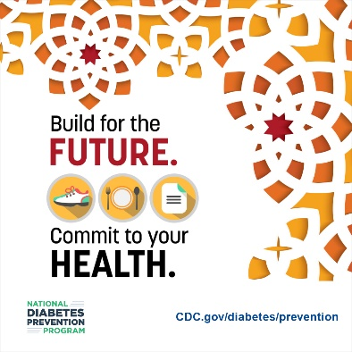  Download Image
With the right tools and information, you can learn how to make healthy food and lifestyle choices. Find the resources you need with CDC’s National Diabetes Prevention Program lifestyle change program. Learn more at [URL]. | 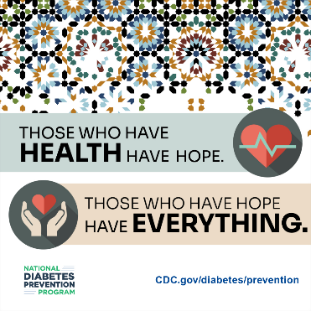  Download Image
Being devoted to your family and friends means prioritizing your well-being. Dedicate yourself to healthy living by making healthy food choices and maintaining an active lifestyle. Join CDC’s National Diabetes Prevention Program lifestyle change program at [URL]. | 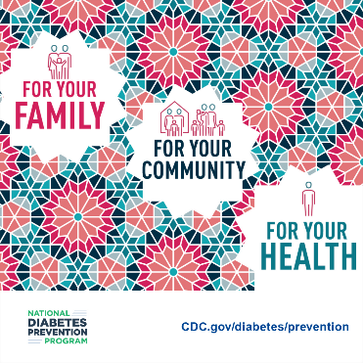  Download Image

