National Diabetes Month 2019 Promotional Materials

National Diabetes Month 2019
Your best life starts here.

Overview & Table of Contents
This year for National Diabetes Month, CDC and ICF Next have developed promotional materials that focus on the trialability of the National DPP lifestyle change program. Trialability allows potential customers to try out a new product or service. According to the Health Communication Capacity Collaborative, trialability is one of the factors that influences how quickly a positive health behavior is adopted (source). The chart below demonstrates how trialability works in conjunction with other marketing strategies.

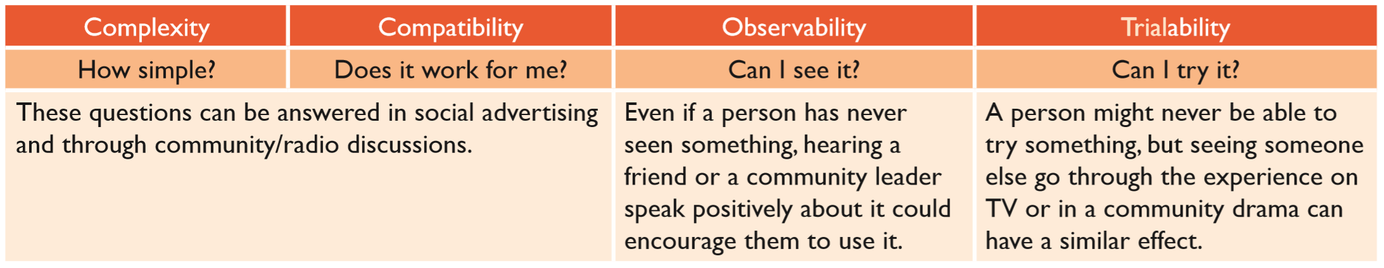
(Source)

With trialability as our focus, you will notice that the National Diabetes Month promotional materials included in this bundle evoke a feeling of “if they can do it, I can do it.” These materials share stories of people who are directly involved with the lifestyle change program, including coaches, program coordinators, program champions, and healthcare providers. The theme, which is interspersed throughout the materials, is “Your best life starts here.” The call to action for each piece is to learn more about the program and try it.

All of the images included in this bundle are available in this zip file.

Contents
Overview & Table of Contents 1
Existing Materials 2
Drop-in Article 1: Program Overview 2
Drop-in Article 2: Profile Piece 3
Email Copy for Potential Participants 4
Email 1 4
Email 2 5
Email Copy for Healthcare Providers 6
Email 1 6
Email 2 7
Social Media Messages 8
Generic National Diabetes Month Social Media Messages 8
Testimonial Video Social Media Messages 9
Telling Your Own Champion’s Stories on Social Media 9
Print Ad/Poster 9
Postcard 9

Existing Materials

In addition to the materials found in this bundle, we also recommend the following materials for targeting healthcare providers:
- Action Guide for Community Pharmacists (CDC)
- Pharmacy, Podiatry, Optometry, and Dentistry Toolkit (CDC)
- Prevent Diabetes STAT Toolkit (AMA)

Drop-in Article 1: Program Overview
To use: Customize this article by filling in the highlighted portions with specific details about your program. You can also replace Cynthia’s story with a story from your own program champion. Additionally, consider updating the callout box to highlight some of your more popular sessions and activities. Then post this article to your organization’s home page as a highlight story, include it in your organization’s publication(s), or post it to the news section of your organization’s website.

Cynthia took control of her health and you can too. Learn how.

Cynthia Johnson didn’t always make health a priority.

“I was overweight, making all the wrong choices,” she says. “I knew I should be doing something, but I wasn’t motivated to do so.”

Then she visited her doctor and found out she had prediabetes, a condition that affects 1 in 3 American adults. Prediabetes means a person’s blood sugar levels are higher than normal but not yet high enough for type 2 diabetes. Her doctor told her it was time to start making some changes in her life, so Cynthia signed up for a CDC-led National Diabetes Prevention Program (National DPP) lifestyle change program. The program offers support with her goals of losing weight, eating healthier, and exercising more. Now she’s lost weight and is feeling better than ever.

November is National Diabetes Month, so it’s the perfect time to try what Cynthia did and join a program that can help you prevent or delay type 2 diabetes. [Insert program name], [part of CDC’s National Diabetes Prevention program OR a CDC-recognized lifestyle change program], is a year-long program designed to help you make lasting lifestyle changes to prevent or delay type 2 diabetes. At [Insert program name], like Cynthia, you’ll learn, laugh, share stories, try new things, and build new habits—all while lowering your risk of type 2 diabetes and improving your health.
Sample Class Topics
- Be a Fat and Calorie Detective
- Move Those Muscles
- Four Keys to Healthy Eating Out
- Talk Back to Negative Thoughts
- Make Social Cues Work for You
- You Can Manage Stress
- Ways to Stay Motivated
- Fats - Saturated, Unsaturated, and Trans
- Balance Your Thoughts for Long-Term Maintenance
- Handling Holidays, Vacations, and Special Events
- Stress and Time Management
- Heart Health
- A Closer Look at Type 2 Diabetes
- Looking Back and Looking Forward

Throughout the program, you will work with a trained lifestyle coach to learn:
- How to eat and prepare healthy dishes without giving up all the foods you love
- How to add physical activity to your life even if you don’t think you have time
- How to deal with stress
- How to maintain the changes you’ve made

“I enjoy the class – we’ve had a lot of laughs,” Cynthia says. “I’ve learned that I need to be in a group setting because we support each other. We help each other and everybody has a different perspective. Our class coach is amazing. She’s a positive person, a cheerleader, and she tells us that even though we make mistakes, they’re not permanent. We can learn from them and maybe make different choices in the future.”

[Add information specific to your program, such as when and where it meets, if there is childcare available, if it’s near any public transportation, if there are classes in Spanish, if there is a cost, etc.]

“After participating in this program, I’m more conscious of what I need to do to live better,” says Cynthia. “I’m doing this for me so that I can live a long and healthy life.”

You can hear more about Cynthia’s story in her video. You can have this kind of success too – your best life starts here. This November for National Diabetes Month commit to better health. Learn more today at [insert program website or phone number].

Drop-in Article 2: Profile Piece
To use: Customize this article by interviewing someone directly involved with the lifestyle change program, such as a coach, program coordinator, program champion, and/or healthcare provider. Then include his/her responses below. You may want to consider following these tips for success:
- Profile someone who is excited about the lifestyle change program and all its benefits.
- Make sure you have permission to share the person’s responses and that you’re clear on how much personal information they are comfortable with you sharing (last name, personal details, etc.). Avoid any potential HIPAA violations.
- Consider adding a photo of the person to go with the story.
- Share the story with the person before it’s finalized to ensure they’re happy with how it turned out.
- Feel free to revise the sample questions below or add your own.
- When adding in the interview responses, be sure they have appropriate context and lead back to your key messages. We’ve added sample responses to give you an idea of what this could look like, but we encourage you to use your own.
Then post this article to your organization’s home page as a highlight story, include it in your organization’s publication(s), or post it to the news section of your organization’s website.

Spotlight on [person’s name], [person’s title related to the lifestyle change program]

This November for National Diabetes Month, we asked [person’s name], [person’s title related to the lifestyle change program], to tell us why preventing or delaying type 2 diabetes is important to [him/her]. Here’s what [he/she] had to say.

Q: An estimated 84 million Americans – or 1 in 3 – have prediabetes, a condition where someone’s blood sugar levels are higher than normal but not yet high enough for a type 2 diabetes diagnosis. With healthy lifestyle changes, people have a better chance of preventing or delaying type 2 diabetes. Why is this something that’s important to you?

A: [Add interview answer with appropriate context. For example, “Preventing or delaying type 2 diabetes is important to me because I know it runs in my family. My grandparents, uncle, aunt, and parents all had it. When my doctor told me I had prediabetes, I knew I didn’t want to be like my grandmother who lost her foot and eventually died due to diabetes complications. I wanted to do something about it.”]

Q: [Insert program name], [part of the CDC’s National Diabetes Prevention program OR a CDC-recognized lifestyle change program], can help people learn how to eat healthier foods, exercise more, and manage stress to prevent or delay type 2 diabetes. How did you first hear about and become involved with [insert program name]?

A: [Add interview answer with appropriate context. For example, “I remember first hearing about PROGRAM NAME through one of my neighbors. I saw that she had lost weight and I asked what her secret was. She told me about PROGRAM NAME and said she was eating healthier and going for more walks around the neighborhood. She told me about some of the fun classes and mentioned that because she had prediabetes, the class was free (covered by insurance). A few months before all this my doctor had told me I had prediabetes, but I hadn’t done anything about it yet. I asked her how to sign up.”]

Q: How would you describe your experience with [insert program name]?

A: [Add interview answer with appropriate context. For example, “My experience with PROGRAM NAME has been amazing. I’ve met a great group of people and have learned so much. We all meet once a week and talk about what we’ve been doing to reach our health goals. Sometimes I will slip up and have a bad week, but my coach always encourages me to learn from my mistake and start over again with healthier choices.”]

Q: What’s your favorite part about [insert program name]?

A: [Add interview answer with appropriate context. For example, “Exercise has always been really hard for me – I’m not the kind of person who has the time or energy to go to a gym. I thought exercise just wasn’t for me. But sometimes before or after class we’ll have a dance party and someone gets to choose the music. We dance around and I work up a sweat. It doesn’t even feel like exercise and it’s really fun!”]

Q: What would you tell someone who is considering participating in [insert program name]?

A: [Add interview answer with appropriate context. For example, “This program really works, and it’s so worth it. It might seem like a big time commitment but what’s a few hours a month for one year of your life if it helps you make changes and live longer? I am proud of the changes I made and how far I’ve come. Change doesn’t happen overnight – you might as well start today.”]

Thank you, [person’s name], for sharing your story with us!

You can have this kind of success too – your best life starts here. This November for National Diabetes Month commit to better health. Learn more today at [insert program website or phone number].

Email Copy for Potential Participants
To use: Throughout November, send this email series to people who have expressed interest in your program. When adding the corresponding photo to the email, be sure to include it in the body of the email instead of attaching it. Also, you may want to hyperlink the photo to the video.

Email 1

Subject: Mike Got Healthier, You Can Too. Your Best Life Starts Here.

Email Copy:

“My motivation is to watch my children grow up and to be here for them.”

Does this sound familiar? This November for National Diabetes Month commit to better health like Mike.

Mike Jones is a retired NYPD police officer who was used to eating on the go, which meant fast food and junk food from vending machines. He knew his parents had diabetes but never thought it would affect him. “I never thought about it,” he says. “I just thought, I’m young. I thought I was healthy.”

Then one day a call from his doctor changed everything – Mike was told he had prediabetes. This is a condition that affects 1 in 3 American adults and means a person’s blood sugar is higher than normal but not yet high enough for a type 2 diabetes diagnosis. Mike didn’t want to be like his parents and have to take insulin every day, so he signed up for a CDC-led National Diabetes Prevention Program (National DPP) lifestyle change program.

At a lifestyle change program like [insert program name], he worked with a trained lifestyle coach to learn how to eat healthy without giving up all the foods he loves, how to add physical activity to his life even when he thinks there isn’t time, how to deal with stress, and how to maintain positive changes.

“They showed me the right things to eat,” says Mike. “Now I cook my own food, like baked chicken, boiled potatoes, and steamed broccoli. I make smoothies with lots of fruits and vegetables. You can use what’s around you – I work out right in my living room or go outside and run around the park. We meet once a week and we talk about what we do in our lives and the changes we’ve made. It gives you a sense of camaraderie. You learn something new every time.”

After completing the program, Mike’s doctor told him his A1C levels, which determine whether you have prediabetes, were closer to the normal range.

“It starts with taking care of myself and my body,” he says. “I’m proud to see how far I’ve come. I feel better, I feel stronger. I have a whole new life ahead. I plan to live life to the fullest.”

You can hear more about Mike’s story in his video. You can have this kind of success too – your best life starts here. Learn more today at [insert program website or phone number].

Email 2

Subject: Cynthia Got Healthier, You Can Too. Your Best Life Starts Here.

Email Copy:

“I was overweight, making all the wrong choices. I knew I should be doing something, but I wasn’t motivated to do so.”

Do these words sound familiar? What about the feeling of not living your best life?

Cynthia Johnson visited her doctor and found out she had prediabetes, a condition where her blood sugar levels were higher than normal but not yet high enough for type 2 diabetes. Her doctor told her it was time to start making some changes in her life, so she signed up for a CDC-led National Diabetes Prevention Program (National DPP) lifestyle change program. The class taught her how to make long-lasting lifestyle changes to improve her health and reduce her risk for developing type 2 diabetes.

“I enjoy the class – we’ve had a lot of laughs,” Cynthia says. “I’ve learned that I need to be in a group setting because we support each other. We help each other and everybody has a different perspective. We share information. Our class coach is amazing. She’s a positive person, a cheerleader, and she tells us that even though we make mistakes, they’re not permanent. We can learn from them and maybe make different choices in the future.”

While participating in the program, Cynthia lost weight and now has more energy.

“I’m more conscious of what I need to do to live better. I’m doing this for me so that I can live a long and healthy life.”

You can hear more about Cynthia’s story in her video. You can have this kind of success too – your best life starts here. This November for National Diabetes Month commit to better health. Learn more today at [insert program website or phone number].

Email Copy for Healthcare Providers
To use: Throughout November, send this email series to healthcare providers who you are in contact with.

Email 1

Subject: Refer Patients with Prediabetes to [Insert program name]

Email Copy:

When you see a patient who has prediabetes, what’s your go-to plan of action? Dr. Irene Snow from Buffalo, NY refers her patients with prediabetes to a CDC-led National Diabetes Prevention Program (National DPP) lifestyle change program to help them prevent or delay a type 2 diabetes diagnosis.

“What I would say to other colleagues is that it works,” she says.

According to national statistics, likely one-third of your patients older than age 18 have prediabetes and are at risk for developing type 2 diabetes. Nine in 10 of those individuals likely do not know of their risk.

You can refer your at-risk patients to a CDC-recognized lifestyle change program such as [insert program name] that is proven by research to cut their risk of type 2 diabetes by more than half. Participating in this program will encourage weight loss and other healthy changes to your patients’ lifestyles, lowering their risk of type 2 diabetes, heart attack, and stroke.

[Insert information specific to your program and how it meets the needs of your community.]

“We saw our patients not only actively participate, but also be successful in the outcomes we were looking for,” says Dr. Snow.

You can hear more from Dr. Snow in her video. Find out more about how to refer your patients to [insert program name] at [insert program website or phone number].

Email 2

Subject: See How One Clinic Helps Patients with Prediabetes

Email Copy:

“All primary care providers see patients day after day who have obesity or who are overweight and have prediabetes,” says Dr. Steven Reed from Park Nicollet Clinic in Brooklyn Park, MN. “It’s not something you can address in a five-minute, end-of-visit discussion or with a pamphlet.”

Is this a challenge you face in your practice? The team from Park Nicollet Clinic has worked out an effective system for referring their patients to a CDC-led National Diabetes Prevention Program (National DPP) lifestyle change program. The lifestyle change program, such as [insert program name], is proven by research to cut participants’ risk of type 2 diabetes by more than half. Participating in this program will encourage weight loss and other healthy changes to your patients’ lifestyles, lowering their risk of type 2 diabetes, heart attack, and stroke.

Julie Cashman, a Registered Nurse at Park Nicollet Clinic, explains the process they follow when referring patients to a program:
- They create a report through their electronic health record system to identify their patients who have prediabetes.
- Each clinician reviews the report to remove any patients who have possible exclusions or barriers to participation in the program.
- The staff sends letters to the patients who appear to be good candidates and refers them to a lifestyle change program in their area.

Through this process, 41% of their patients who received a letter enrolled in the program.

“The National Diabetes Prevention Program is something bigger you can give your patients that’s clinically proven and available nationwide,” says Dr. Reed.

[Insert information specific to your program and how it meets the needs of your community.]

You can hear more about how the team at Park Nicollet Clinic is helping patients with prediabetes in this video. Find out more about how to refer your patients to [insert program name] at [insert program website or phone number].

Social Media Messages

Generic National Diabetes Month Social Media Messages
To use: Each bullet represents a different social media post. Use hashtags only when posting on Twitter or Instagram; hashtags are not recommended for use on Facebook. All of the posts below have fewer than 280 characters, which is the limit for Twitter. For these generic posts, try to use your own photos so the posts feel authentic. If you don’t have any photos of your own, you can use stock photos that represent your target audience.

- If you are 45 or older, are overweight, have a family history of type 2 diabetes, or had #diabetes while you were pregnant, you may be at risk for #type2diabetes. Lower your risk with a proven program. Learn more: [Insert program website or phone number] #DiabetesMonth

- You do so much when it comes to the health of your children, your family and friends, and even your coworkers. What do you do for yourself? [Insert program name] can help you reduce your risk of developing #type2diabetes. [Insert program website or phone number] #DiabetesMonth

- Did you know? #Type2diabetes is a serious disease. [Insert program name], a National Diabetes Prevention Program lifestyle change program, can teach you to prevent or delay #type2diabetes by eating healthier and moving more. What are your favorite healthy foods? #DiabetesMonth

- It’s #DiabetesMonth! Having #prediabetes puts you at higher risk of developing #type2diabetes. [Insert program name] can help you prevent or delay #type2diabetes through healthy eating, reducing stress, and increasing physical activity. What’s your favorite way to stay active?

- Stress is a factor that can contribute to poor health. This includes #prediabetes, which is a risk factor for #type2diabetes. We want to hear from you. What are some techniques you use to reduce stress? #DiabetesMonth

Testimonial Video Social Media Messages
To use: Copy and paste the hyperlink for each video into a Facebook or Twitter post. Then add the relevant post content. Use hashtags only when posting on Twitter or Instagram; hashtags are not recommended for use on Facebook.

Video Link | Post Content
Cynthia’s Story | “I was overweight, making all the wrong choices. I knew I should be doing something, but I wasn’t motivated to do so.” Cynthia took control of her health by joining a CDC-led National Diabetes Prevention Program lifestyle change program. “Now I’m more conscious of what I need to do to live better,” she says. “I’m doing this for me so that I can live a long and healthy life.” You can have this kind of success too – your best life starts here. This November for National #DiabetesMonth commit to better health. Learn more today at [insert program website or phone number].
Mike’s Story | Mike reversed his #prediabetes by joining a CDC-led National Diabetes Prevention Program lifestyle change program. “I’m proud to see how far I’ve come,” he says. “I feel better, I feel stronger. I have a whole new life ahead. I plan to live life to the fullest.” You can have this kind of success too – your best life starts here. This November for National #DiabetesMonth commit to better health. Learn more today at [insert program website or phone number].
Suzi’s Story | Suzi took control of her health by joining a CDC-led National Diabetes Prevention Program lifestyle change program. “I’m so much healthier now, I have so much more energy and I’m going out and walking a lot more than I used to.” You can have this kind of success too – your best life starts here. This November for National #DiabetesMonth commit to better health. Learn more today at [insert program website or phone number].
Corinne’s Story | Corinne took control of her health by joining a CDC-led National Diabetes Prevention Program lifestyle change program. “My kids have never seen me run, and I can now. And I love it.” You can have this kind of success too – your best life starts here. This November for National #DiabetesMonth commit to better health. Learn more today at [insert program website or phone number].

Telling Your Own Champion’s Stories on Social Media
Once you’ve gathered a testimonial for Drop-In Article #2 above (the Profile Piece), consider repurposing the answers for social media posts. Be sure you have permission to share this person’s story on social media then follow these tips for success:

- Step 1: Choose answers from the interview that work well as a soundbite and can stand on their own with little context. You’ll also want to choose answers that are less than 280 characters for Twitter.

- Step 2: Use quotation marks and add the person’s name, as seen in the testimonial video social media posts above.

- Step 3: Add any relevant calls to action (your website or phone number) and #DiabetesMonth.

- Step 4: Include a photo of the person if you have one. However, if you have multiple posts, avoid using the same photo every time (e.g., if you have four posts but only one photo, consider using the photo just once or twice, and not in back-to-back posts).

Print Ad/Poster
To use: Download the print ad/poster for your target audience from the zip file. Then you can print it out and use it as a poster or share it with your local newspaper as a print ad. The bottom of the poster has fillable space for you to add your own details. You can also customize the print ad/poster with your own photos and testimonials.

Print ad/poster for African American audiences
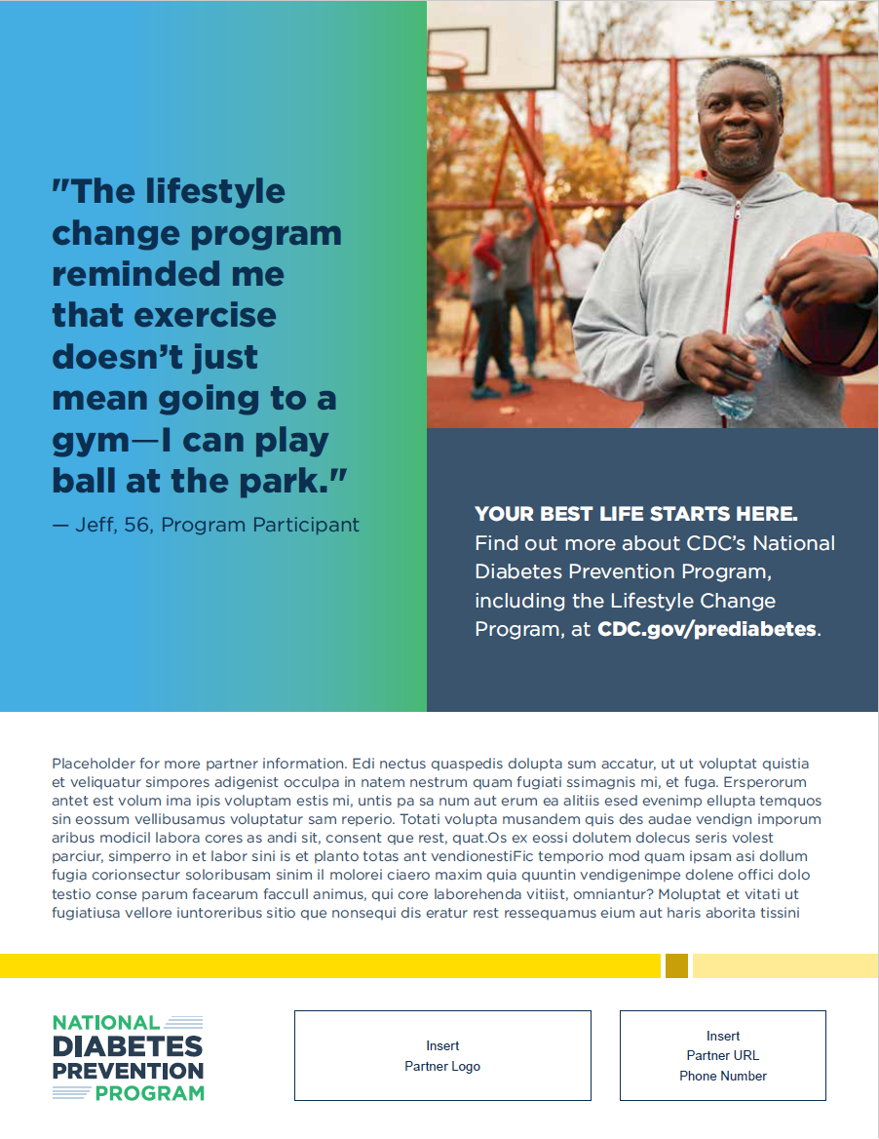
Print ad/poster for men/age 65+ audiences
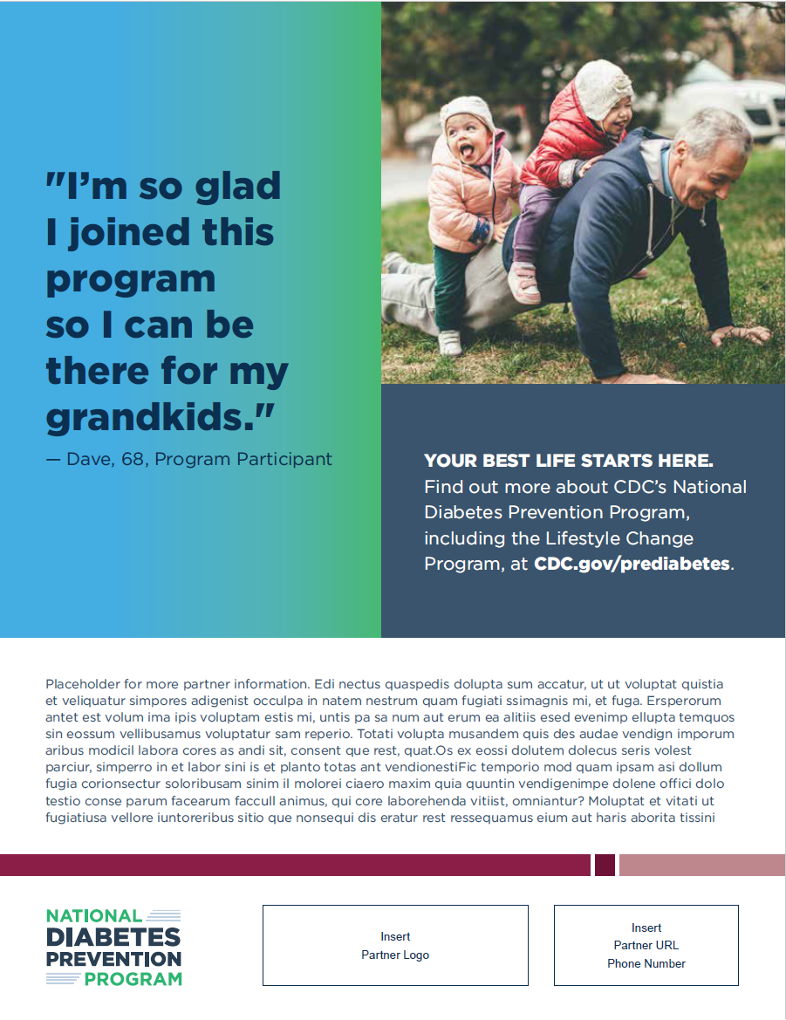

Print ad/poster for Hispanic/Latino audiences (English)
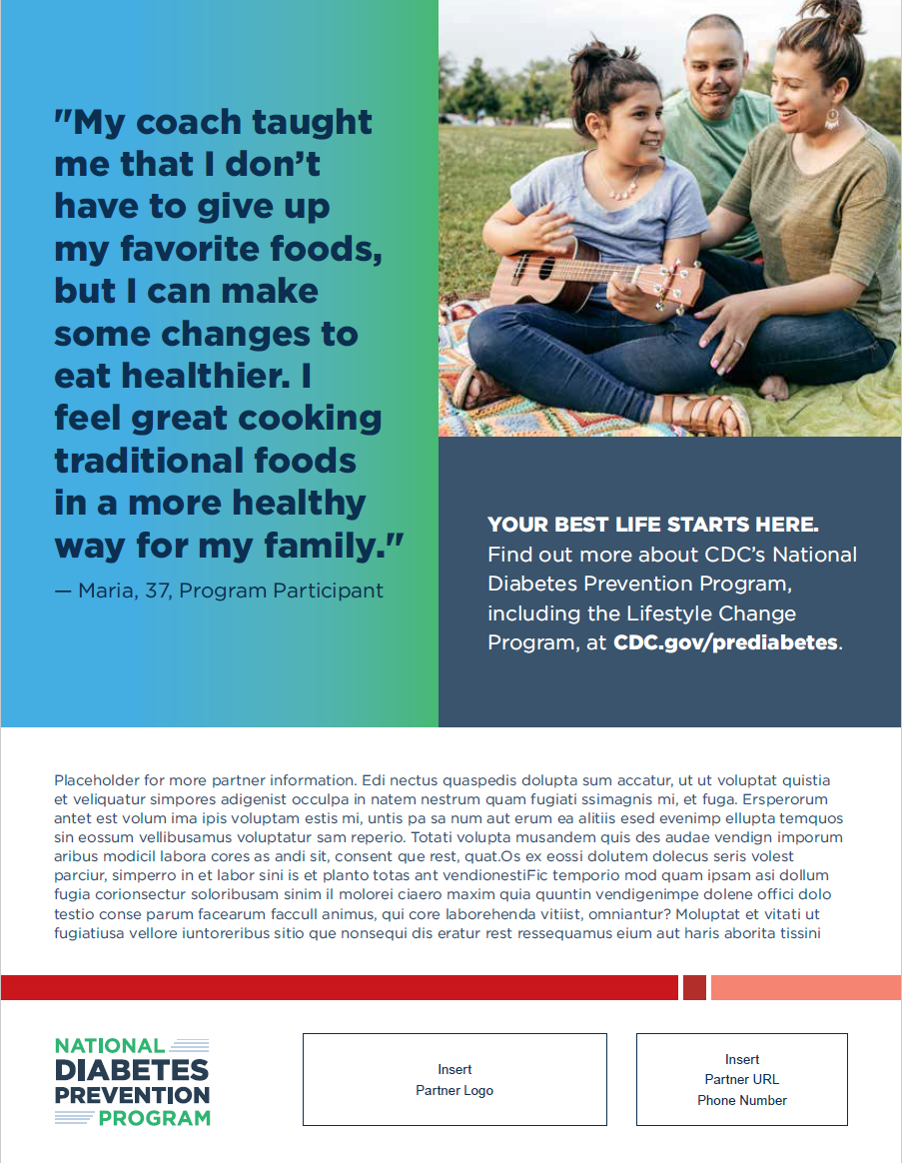

Print ad/poster for Hispanic/Latino audiences (Spanish)
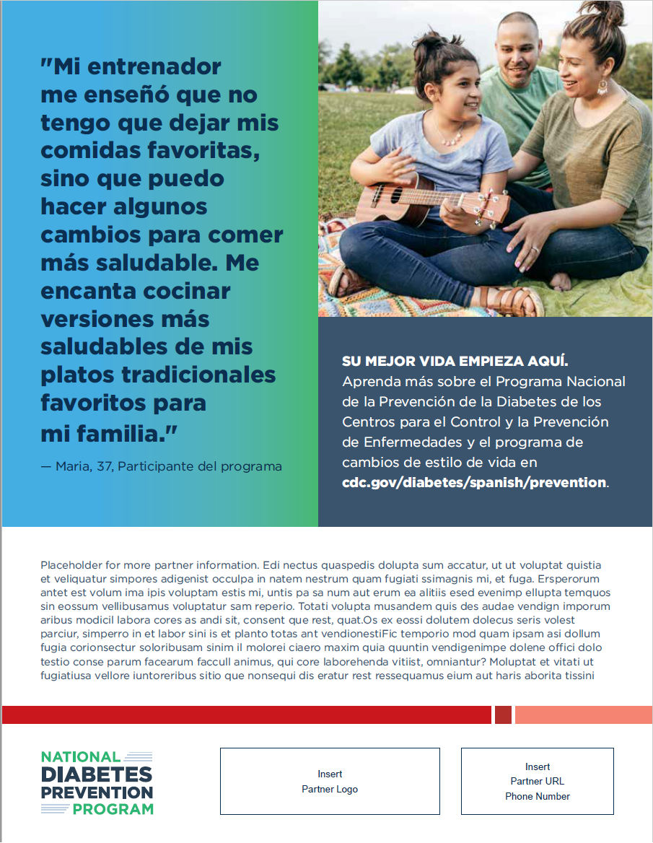

Postcards
To use: Download the post card for your target audience from the zip file. Then you can print it out and use it as a poster or share it with your local newspaper as a print ad. The bottom of the poster has fillable space for you to add your own details. You can also customize the print ad/poster with your own photos and testimonials.

Postcard for African American audiences (horizontal)
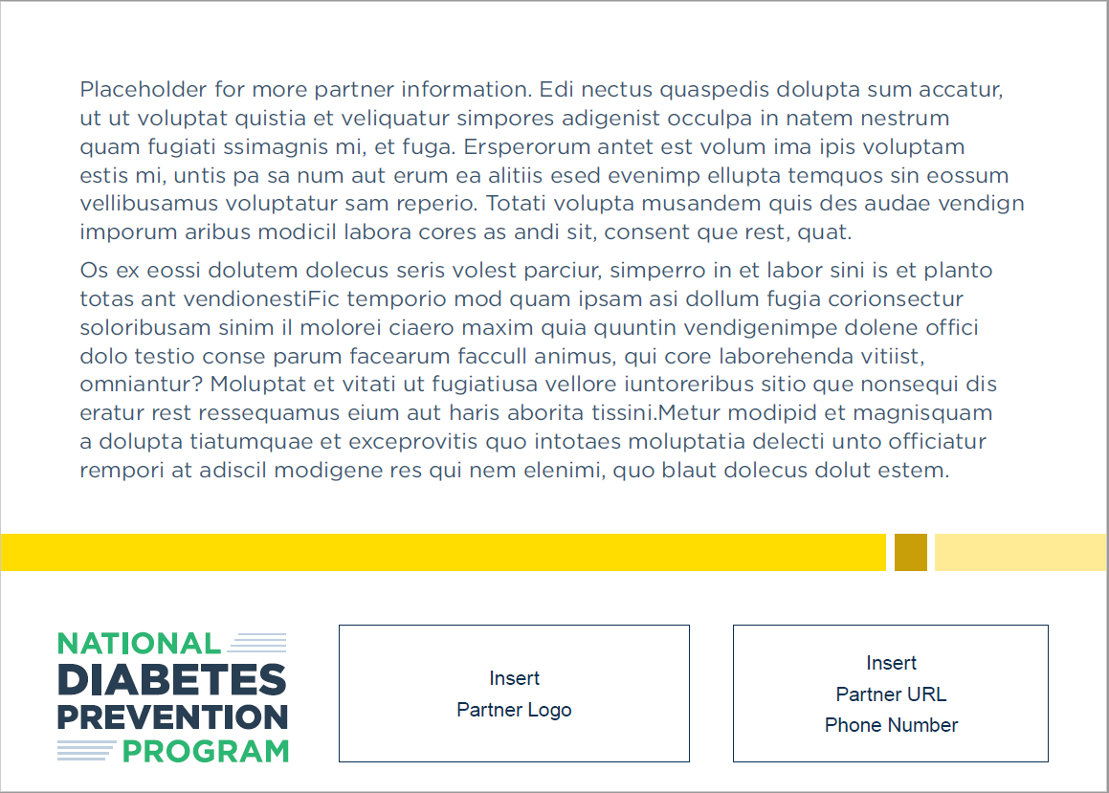
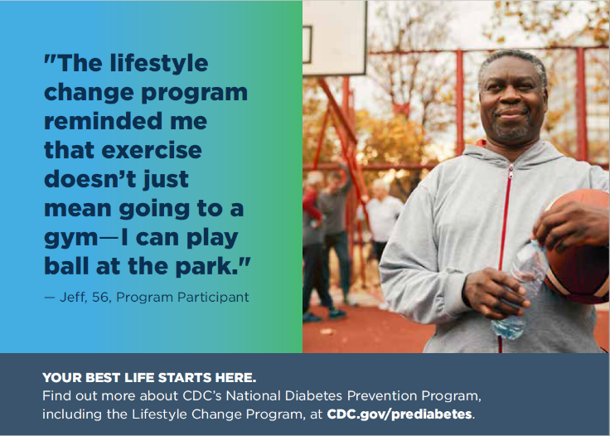
Back
Front

Postcard for African American audiences (vertical)
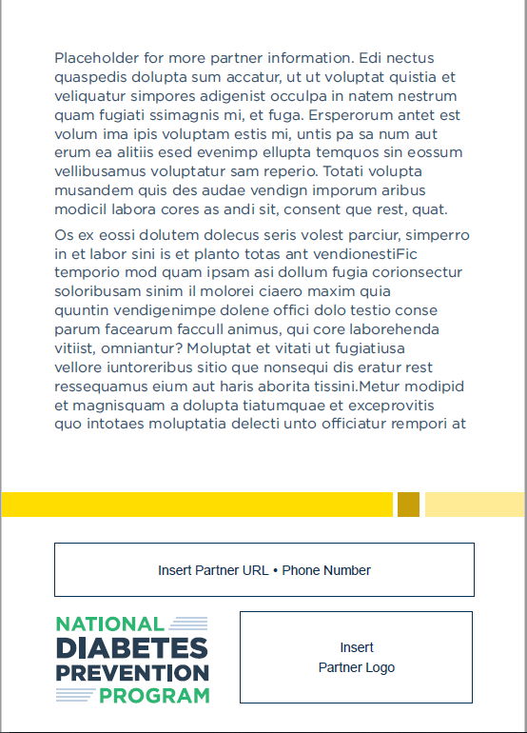
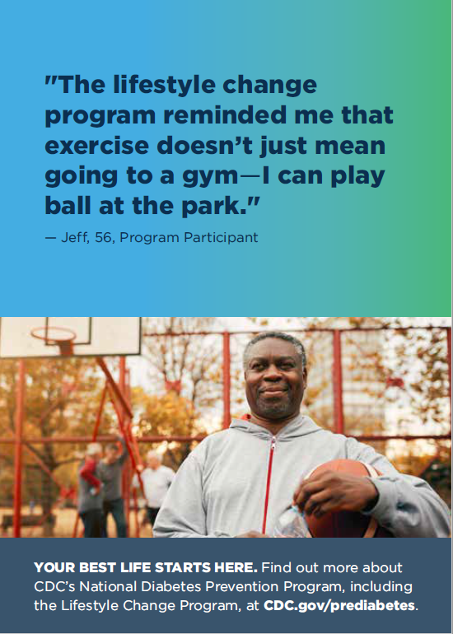
Back
Front

Postcard for men/age 65+ audiences (horizontal)
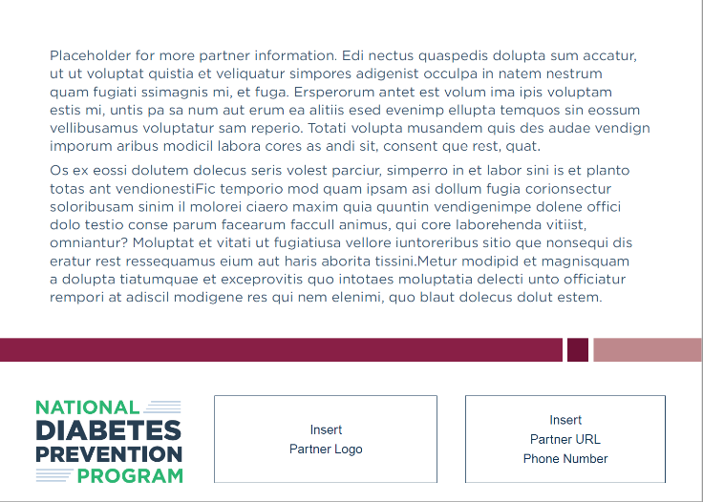
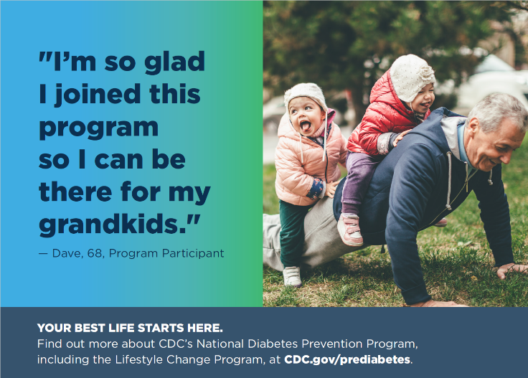
Back
Front

Postcard for men/age 65+ audiences (vertical)
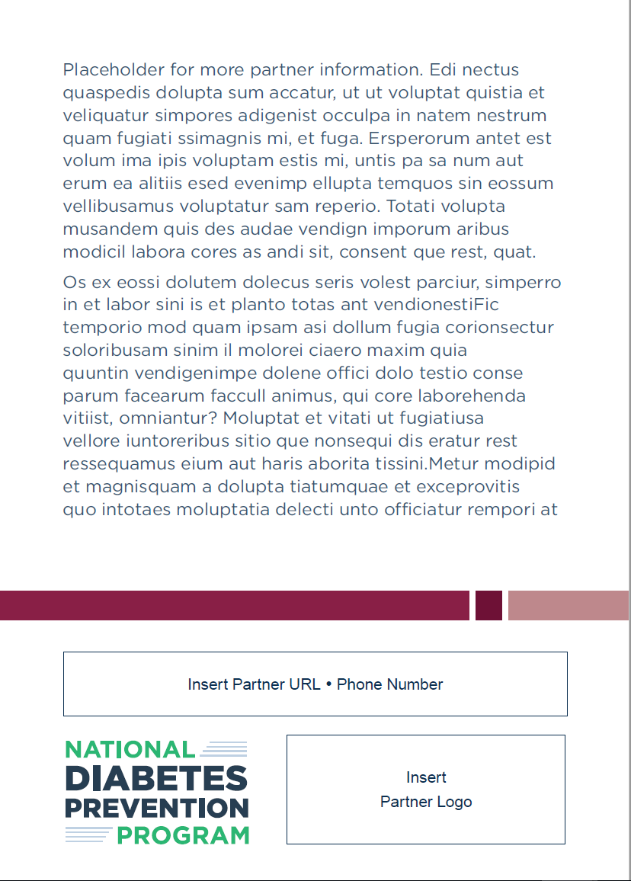
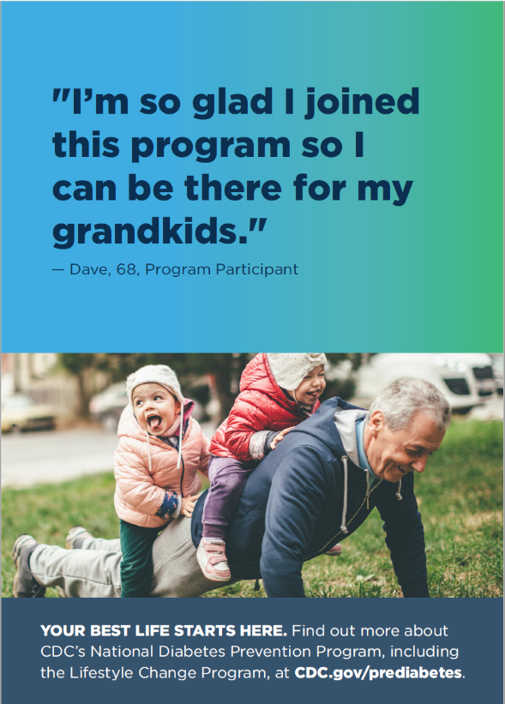
Back
Front

Postcard for Hispanic/Latino audiences (English, horizontal)
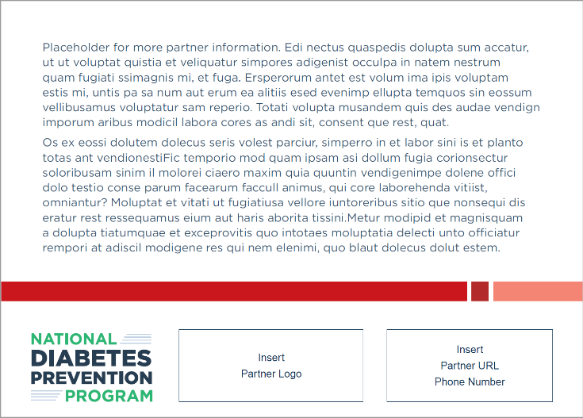
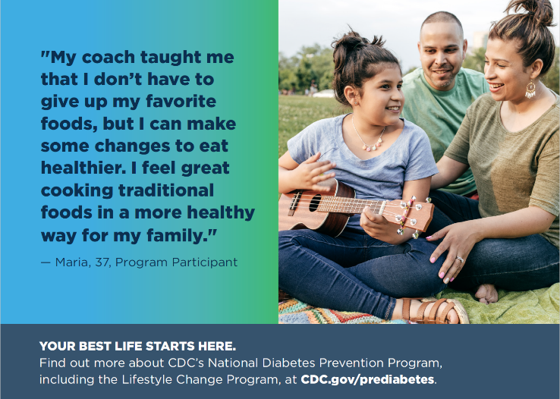
Back
Front

Postcard for Hispanic/Latino audiences (English, vertical)
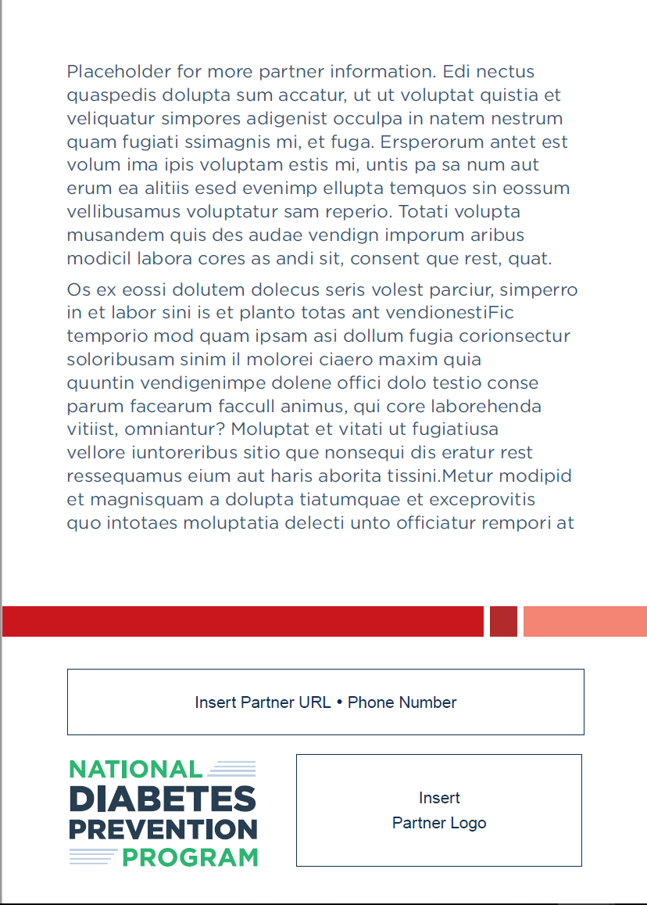
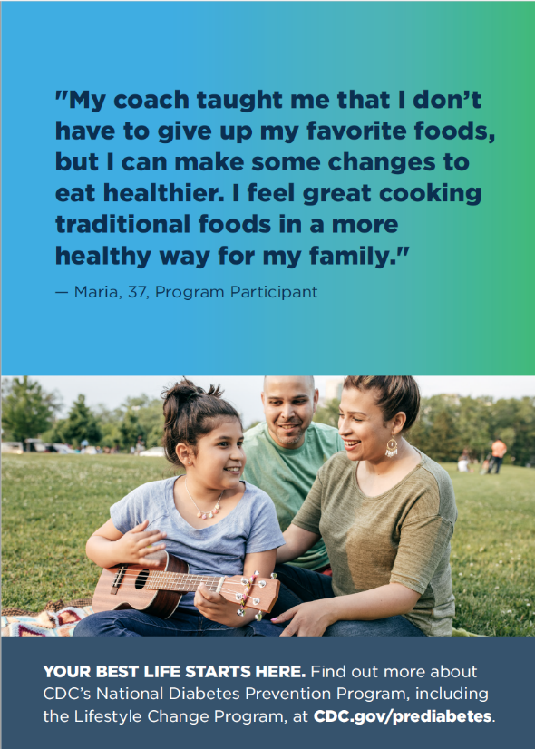
Back
Front

Postcard for Hispanic/Latino audiences (Spanish, horizontal)
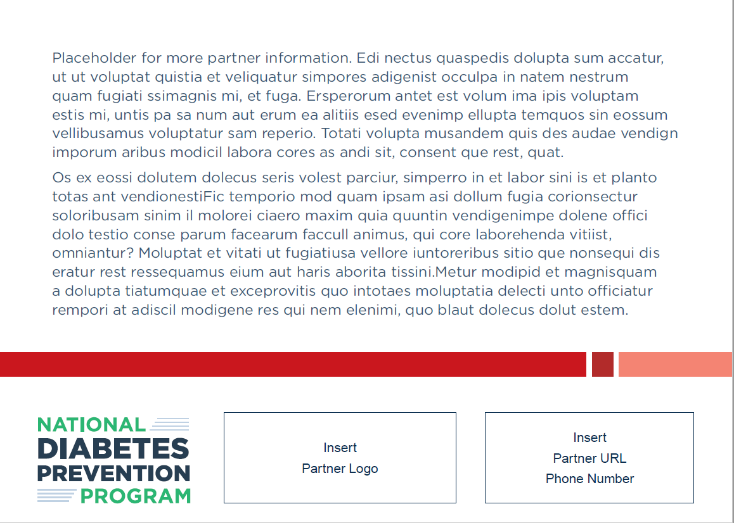
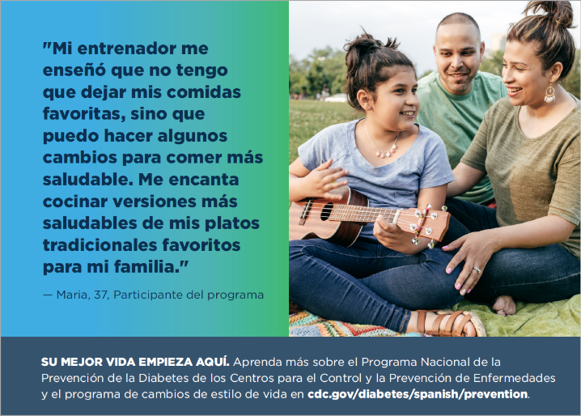

Back
Front

Postcard for Hispanic/Latino audiences (Spanish, vertical)
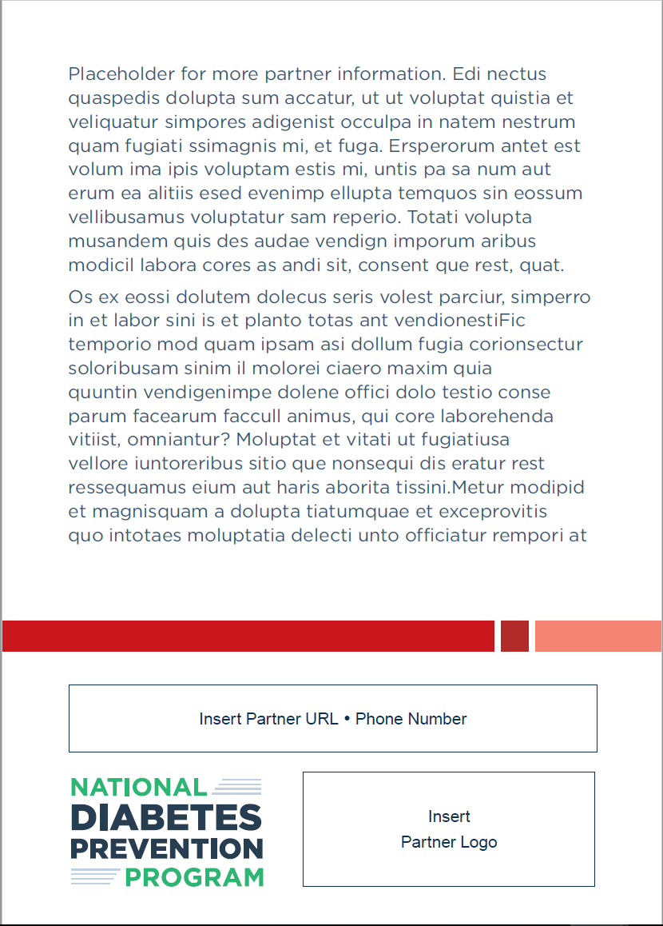
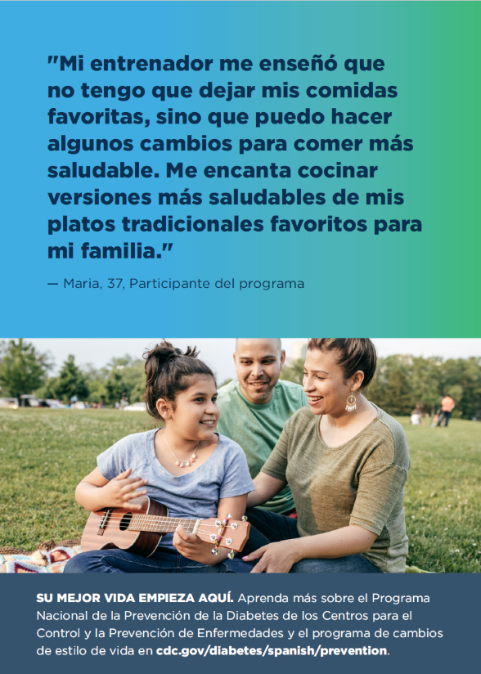

Back
Front

